Table of figures and features

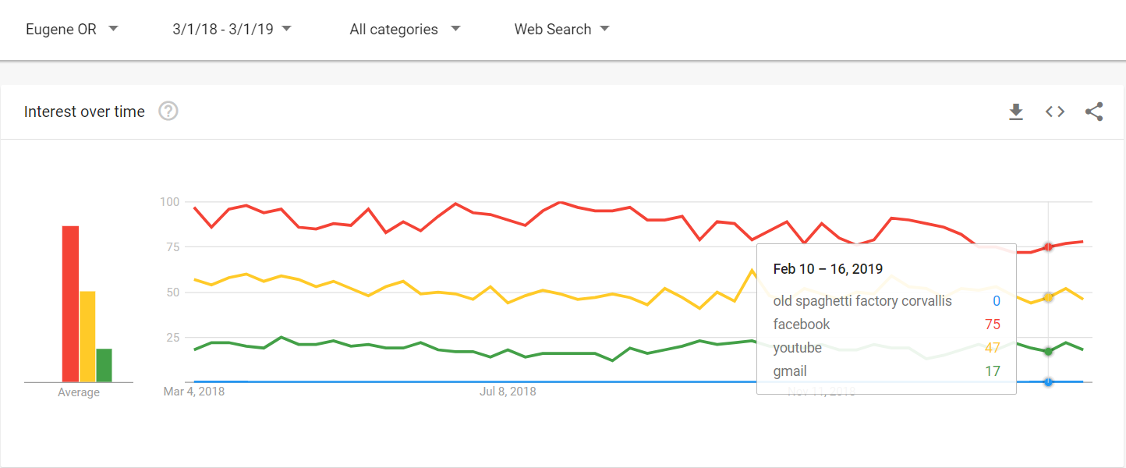

*Figure 1*

*Anchor terms used to scale search terms in the Eugene Area from 01/01/2018 and 12/31/2019*

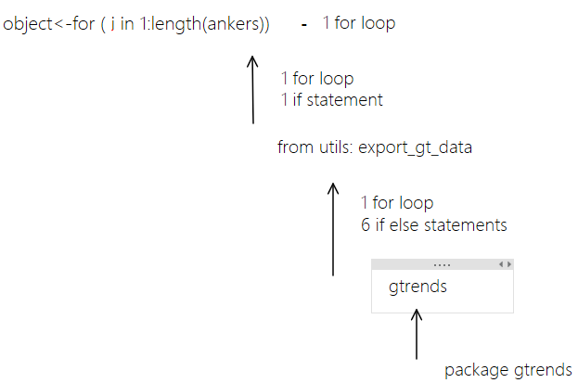

*Figure 2*

*Nested for loop that gathers data on anchor terms but depends on 2 other functions that are also for loops to do so*

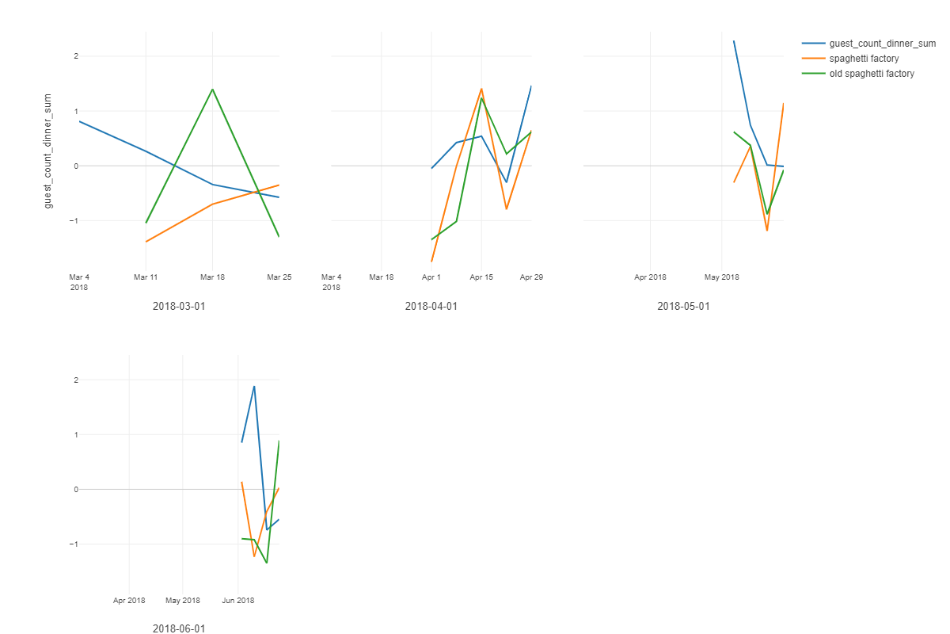

*Figure 3*

Guest counts and search term activity visualized over two months

|  |  |  |  |  |  |  |
| --- | --- | --- | --- | --- | --- | --- |
| Term | Coefficient | Std Error | t Ratio | P Value | Conf High | Conf Low |
| (Intercept) | 1715.66747 | 34.26999 | 50.0632667 | 0.0000000 | 1782.83664 | 1648.49829 |
| old spaghetti factory | 24.21650 | 43.52042 | 0.5564401 | 0.5804951 | 109.51652 | -61.08351 |
| spaghetti factory | -20.55753 | 43.51396 | -0.4724353 | 0.6387571 | 64.72984 | -105.84490 |
|  |  |  |  |  |  |  |

Figure 4

Results from linear regression model Linear Regression with Keyword behavior - Coef. Table

|  |  |
| --- | --- |
| Feature name | Description |
| date | YMD of recorded data |
| day_week | Day of the week |
| special_event | Recorded if there were special events such as athletic events or school graduations |
| 6_week_lun | the 6 week trend of average guest counts for that week day at lunch |
| 6_week_din | the 6 week trend of average guest counts for that week day at dinner |
| lun_ly | last years guests for lunch shifted for the day of the week (date-1,incomplete) |
| din_ly | last years guests for dinner shifted for the day of the week (date-1, incomplete) |
| din_2y | two years ago guests for dinner shifted for the day of the week (date-2, incomplete) |
| pred_lunch | The managers educated guess as to the amount of guest counts expected for that day at lunch |
| pred_din | The managers educated guess as to the amount of guest counts expected for that day at dinner |
| lunch_sales | Total sales at lunch that day (incomplete) |
| dinner_sales | Total sales of dinner that day (incomplete) |
| guest_count_lunch | Total guests for lunch for the given day |
| guest_count_dinner | Total guests for dinner for the given day |
| ppl_res_lun | Total people that are in reservations for lunch on the given day |
| ppl_res_din | Total people that are in reservations for dinner on the given day |
| temp_avg | The average Temperature for the day |

Figure 5

Table of features